**Arab Academy for Science, Technology and Maritime Transport**

**College of Engineering and Technology**

**Computer Graphics (CC416)**

**Final Project Report**

**___________________________________________**

**Submitted to:**

Dr. Gouda Ismail

Eng. Hossam ElZayady

Eng. Reem ElSamahy

**Submitted by:**

Ahmed El-Hussein Ahmed 19106798

Zeyad Ahmed Samer 20106344

# Scene Screenshots:

**Morning Scene with Plane:**

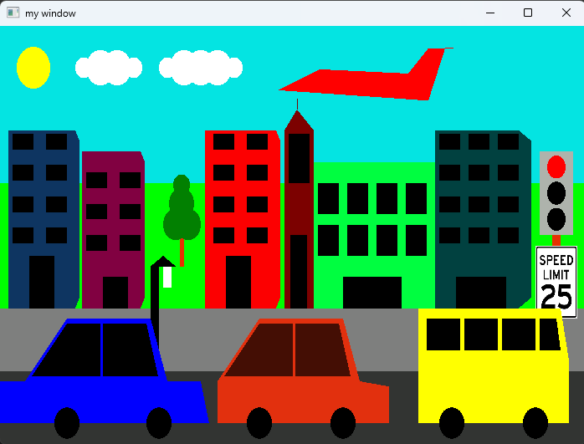

**Morning Scene without Plane:**

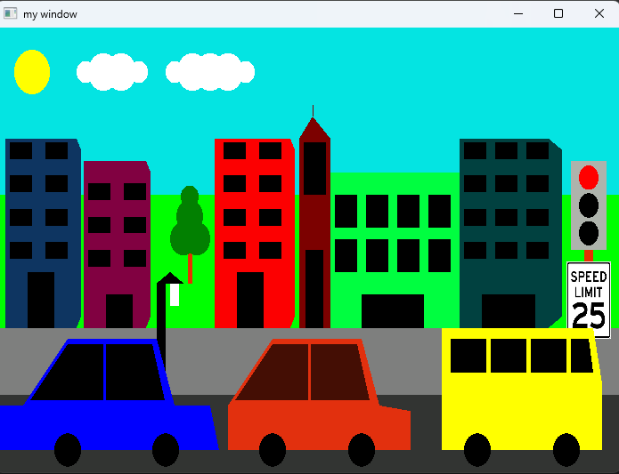

**Sunset Scene:**

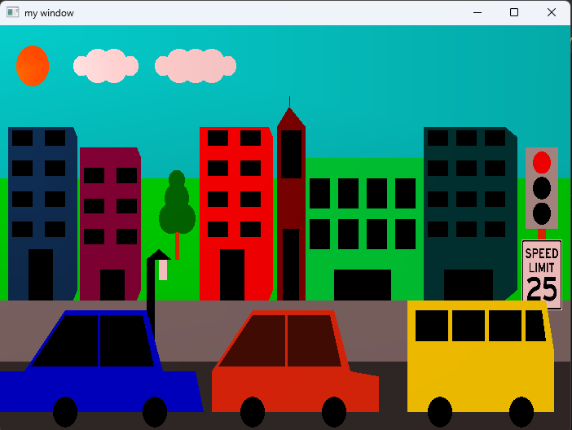

**Night Scene:**

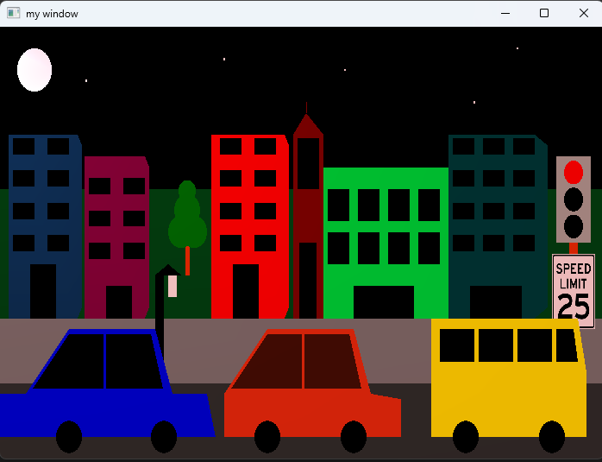

**Night Scene with Rain Effect:**

